GUIDELINES FOR THE
RECONSIDERATION
OF INSTRUCTIONAL MATERIALS:

MATERIALS ALREADY
IN USE

F.C.P.S. Regulation 500-39

Frederick County Public Schools
Department of Media Services
7630 Hayward Road
Frederick, Maryland 21702

September 1993
Revised September 2007

Board of Education of Frederick County

Kathryn B. Groth, President
Jean A. Smith, Vice President

Daryl A. Boffman Bonnie M. Borsa

Donna J. Cook Leslie A. Mansfield

Micheal E. Schaden

Neha Kapoor
Student Member

Our Mission is Teaching for Quality Learning for All Students

The Board of Education of Frederick County does not discriminate in admissions, access, treatment, of employment in its programs and activities on the basis of race, color, gender, age, national origin, religion, or disability.

TABLE OF CONTENTS

Foreword. . . . . . . . . . . . . . . . . . . . . . . . . . . . . . . . . . . . . . . . . . . . . . . . . . . . . . . . .. iv

Board of Education Policy (501) ..,. . . . . . . . . . . . . . . . . . . . . . . . . . . 1

Board of Education Regulation (500-39) . . . . . . . . . . . . . . . . . . . . . . . . . . 2

Request for Reconsideration of Instruction Material Form . . . . . . . . . . . . 5

Procedures for Reconsideration of Instructional Materials Chart . . . . . . . . . . . . . . . .6

Appendices

A. Criteria for Selection of Instructional Materials . . . . . . . . . . . . . . . . . . . 8

Criteria for Books. . . . . . . . . . . . . . . . . . . . . . . . . . . . . . . . . . . . . .. 9

Criteria for Nonbook Material . . . . . . . . . . . . . . . . . . . . . . . . . . . . . . 11

Criteria for Library Media Materials . . . . . . . . . . . . . . . . . . . . . . . . . . 13

Criteria for Plays . . . . . . . . . . . . . . . . . . . . . . . . . . . . . . . . . . . . . . . . . 15

Criteria for Career Education Materials . . . . . . . . . . . . . . . . . . 16
Specialized Criteria . . . . . . . . . . . . . . . . . . . . . . . . . . . . . . . . . . . . 17

Computer Software Approval Process . . . . . . . . . . . . . . . . . . . . . . . . . 18

C. Regulation 400-51 . . . . . . . . . . . . . . . . . . . . . . . . . . . . . . . . . . . . . . . . . . . . 27

Films, Videos, and Audio Recordings Use as Supplementary Materials 27

Parent or Guardian Film/Video Permission Form . . . . . . . . . . . . . . . . . 29
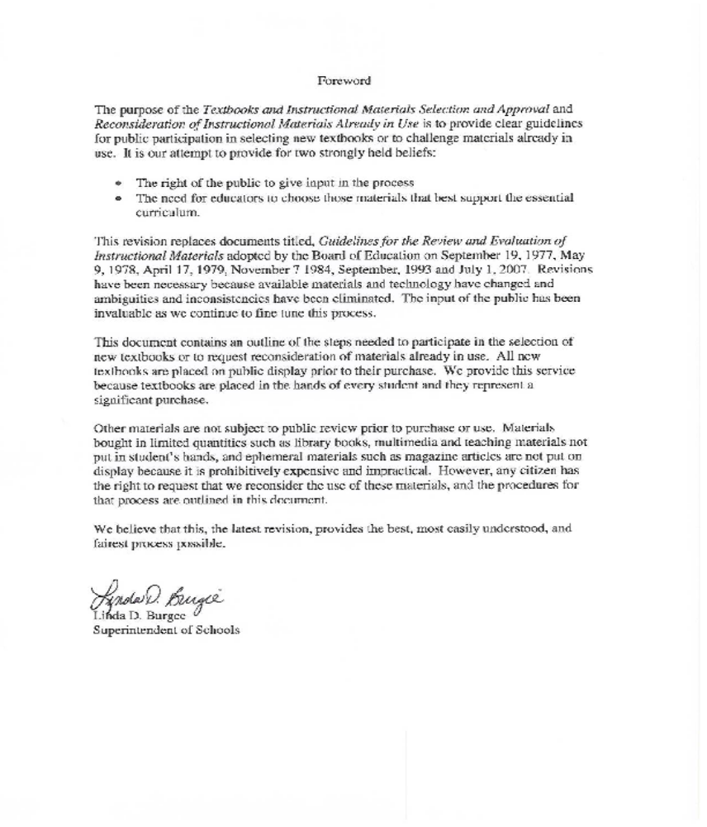

Selection and Review of Instructional Materials

Board of Education Policy (501)

Reconsideration of Instructional Materials Already in Use

Board of Education Regulation 500-39

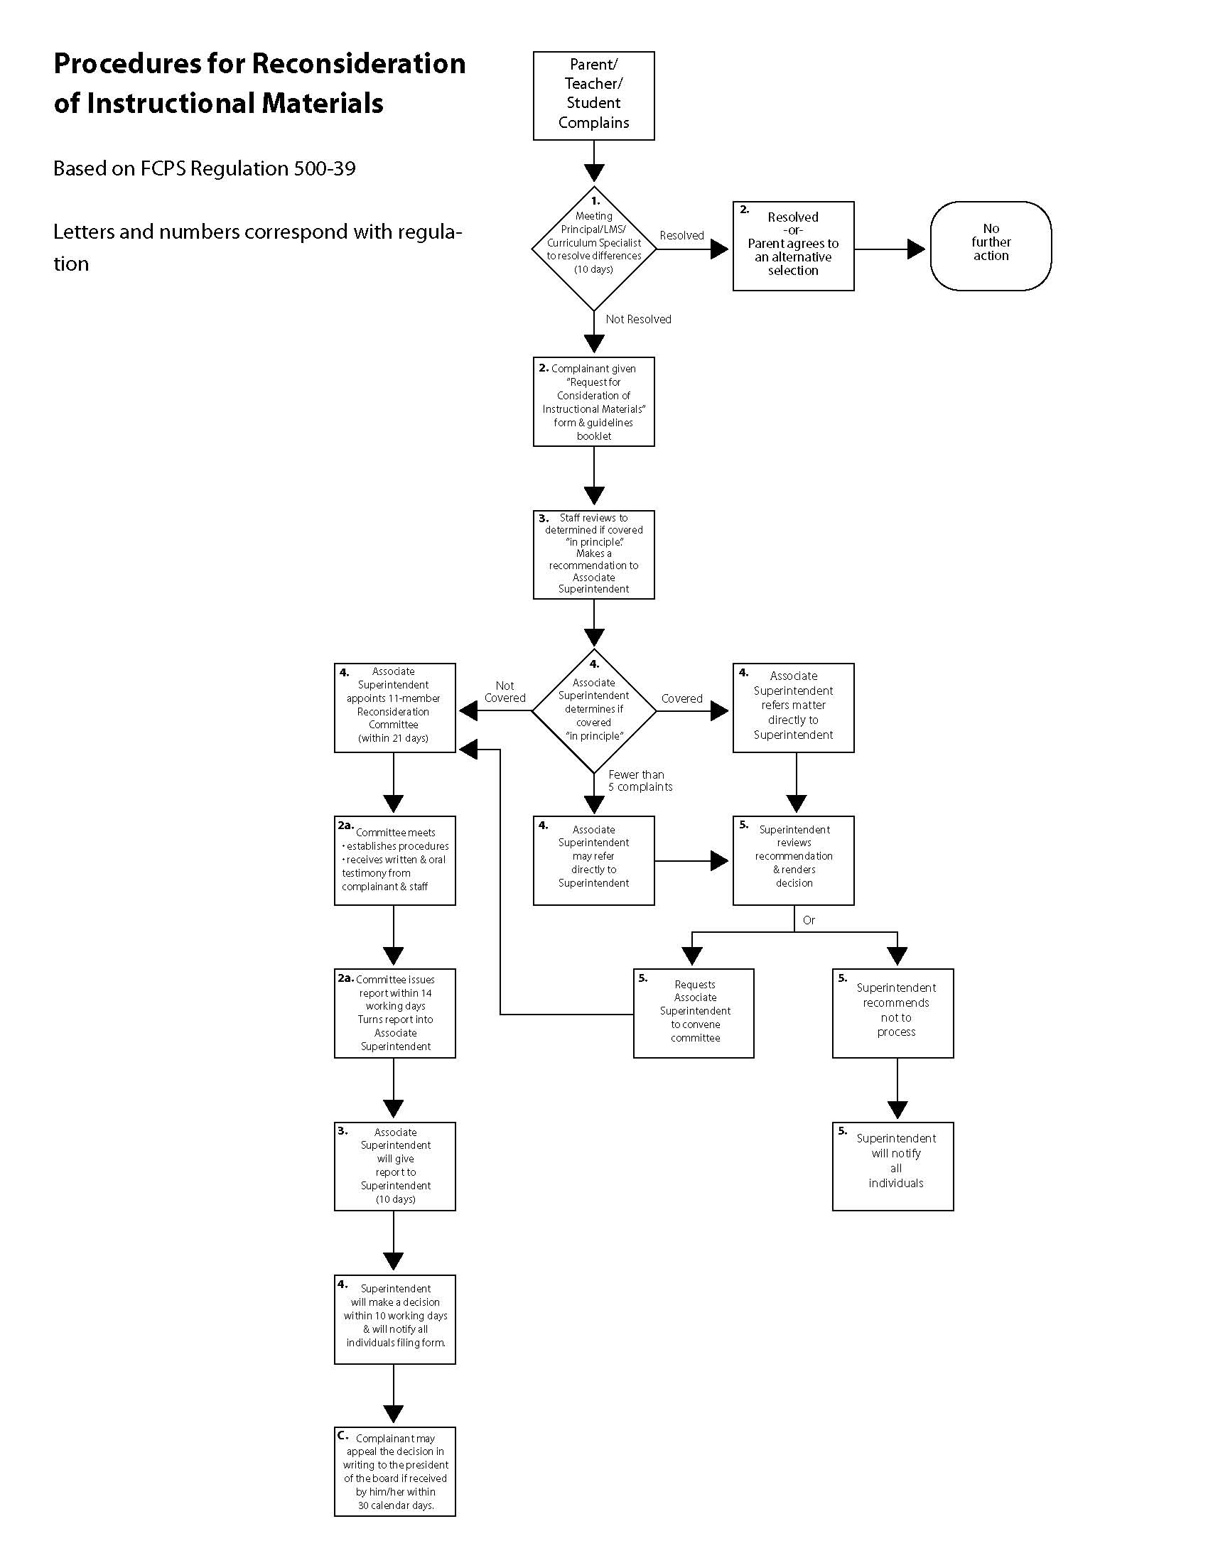

APPENDICES

Criteria for the Selection of Instructional Materials

A. General Criteria. The most important objective is to locate and make available for students and staff members instructional materials that support and achieve the school system's principle goals. To assist those persons selecting materials, certain general criteria must be applied to anything purchased, given, loaned, or rented for instructional use.

1. Materials should support the curricular goals of the school system and individual school programs.

2. Materials should be interesting, accurate, stimulating, and contain content that is significant.

3. The concepts presented should be within the understanding of students who will use the materials and provide for a diversity of interests and levels of ability.

4. Materials should be well-balanced according to the content areas of the curriculum, be varied according to the type of media, and provide for a diversity of interests and levels of ability.

5. Materials should contribute to lifelong learning by widening boundaries of thought presenting a realistic picture of life, developing an understanding of people, and fostering positive values.

6. Materials should have a format, style, and presentation of high quality and be appropriate to expression of the idea, concept, or lesson.

7. Materials should present different points of view.

8. Materials should justify the cost in relation to anticipated use.

9. Materials should be kept current.

10. Principles of learning should have been followed and incorporated in the development of the materials.

11. Technology - based instructional products must provide students with disabilities equivalent access unless this causes significant difficulty or expense.

B. Criteria for Books. In selecting a book, three primary considerations must be made:
(1) What is the purpose, theme, message of the book? (2) How well is this purpose accomplished? (3) For whom is the book intended? After answering these three questions, the following criteria must be used as guidelines for the selection of instructional materials. A curriculum specialist will follow appropriate procedures for adoption when instructional materials conform to a majority of the applicable criteria for selection.

 |  | Yes | No | N/A
1. | Purpose
 | Does the book promote the educational goals and objectives of the curricula of Frederick County Public Schools?
 | Does the book offer an opportunity to better understand and appreciate the aspirations, achievement and problems of the reader and/or other people?
2. | Author and Publisher
 | Is the author qualified?
 | Is the publisher reputable?
3. | Content
 | Does a book about modern times give a realistic picture of life today?
 | Does the book avoid an oversimplified view of life?
 | Does the book avoid religious, sexual, or other cultural biases?
 | Are the facts presented accurately?
 | Is the book objective in presentation?
 | Are the concepts presented appropriate to the ability and maturity of the potential reader?
 | Does the book have logical plot construction and/or development?
 | Does the book consistently reflect the time and setting presented?
 | Are information sources well documented?
 | Are translations and retellings faithful to the original?
 | Are characters created with individual human qualities?
 | Is the language appropriate to the treatment of the topic?
 | Does the book have literary value?
 | Does the book reflect concerns of significance to society?
 | Is the book of interest to its intended audience?
 | Does the book make a significant contribution to the history of literature of ideas?
 | Have the principles of learning been followed in the development of the book?
 | Are student aids to learning provided if appropriate?
 | Is the index adequate?
 | Do the visual aids contribute to the development of the book?
 | Is the copyright date a significant factor in evaluating the usefulness of the content?
4. | Technical Quality
 | Is the size of the book appropriate for use at the intended level?
 | Is the binding durable and strong?
 | Is the cover attractive?
 | Is the paper durable and opaque?
 | Is the font clear and easy to read?
 | Is the type size appropriate for the level intended?
 | Are the page layouts well designed?
 | Are the margins ample?
 | Is the space between the lines appropriate for the level intended?
 | Are the visuals appropriate and in good taste?
 | Do the visuals avoid stereotypes?
 | Are the visuals realistic in relation to the story?
 | Are the captions readable?
 | Are illustrations located properly for greatest usefulness? Is the art or photographic quality acceptable?
5. | Supporting Opinion
 | Does the book appear on one or more reputable book lists or review sources?
 | Has the book been favorably reviewed by experts in the field?

C. Criteria for Nonbook Materials

 |  | Yes | No | N/A
1. | Authenticity
 | Are the facts accurate?
 | Are the facts impartially presented?
 | Is the information up-to-date?
2. | Appropriateness
 | Is the vocabulary at the user's level?
 | Are the concepts at the user's level?
 | Does the presentation encourage the extension of vocabulary and concepts?
 | Are the data useful?
 | Is there a media-subject correlation such as art prints to art, specimens to science?
 | Are the titles, captions, etc. related to the subject?
 | Is the material suitable for group and/or individual use?
3. | Scope
 | Is there full coverage as indicated?
 | Does this means allow for superior concept development?
 | Does the content satisfy the demands for current subjects?
4. | Interest
 | Does the material have a relationship to the user’s experience?
 | Does it provide intellectual challenge?
 | Does it satisfy the user’s curiosity?
 | Does it pass the test of credibility?
 | Does it encourage use of the imagination?
 | Does it have emotional appeal?
 | Does it have sensory appeal?
5. | Organization
 | Does the content develop logically?
 | Are the sequences pertinent to the purpose of the material?
 | Is there balance in the use of narration and dialogue, music and sound effects, and background elements?
6. | Technical Aspects
 | Is there tone fidelity?
 | Is there clarity?
 | Is the speech intelligible?
 | Are the pictures in focus?
 | Are the size relationships true?
 | Is the composition unified?
 | Is there effective use of color?
 | Is there complete synchronization of sound and image?
7. | Special Features
 | Are there descriptive notes and/or a guide or manual?
 | Is there pertinent accompanying material?
 | Does it provide students with disabilities equivalent access?
8. | Physical Characteristics
 | Is the material simple to store and handle?
 | Is minimum instruction required for individual use?
 | Is the packaging attractive?

D. Criteria for Library Media Materials. Library media materials shall be selected from standard, authoritative, bibliographic references using the criteria established in the guidelines. Those materials vary in level of difficulty, format, title, and subject, and usually are purchased in single copies. It is impractical to provide copies of these materials for preview before purchase because of a lack of space for display, time, staff required, and cost of additional preview copies.

Representative List of Bibliographic Sources and Review Journals. A favorable review or
listing of any title in one of the following reviewing journals or bibliographic sources constitutes
approval of the title for addition to media center collections in the Frederick County public schools.

Title
AAAS Science Books and Films
Alan Review
American Association of School Librarians
American Biology Teacher
American Library Association
Best Books for Children
Book Links

...

Booklist
Book Report-Linworth Publishing
Bulletin of the Center for Children's Books
Childhood Education
Children's Catalog with Supplements
Choice
Criticas
Elementary School Library Collection
French Review
German Quarterly
Hispania
Horn Book Magazine
Instructor
Journal of Aesthetic Education
Journal of Geography
Junior High School Library Catalog with Supplements
Kirkus Reviews
KLIATT
Library Journal
Library Media Center
Library Talk
Literature for Today's Young Adults
Media and Methods
Middle & Junior High School Library Catalog
Modern Language Journal
Newbery and Caldecott Medal Books
New York Times Book Review Section
Physics Teacher
Publishers Weekly
Reading Teacher
School Library Journal
School Library Media Monthly
Science Books and Films
Scientific American
Senior High School Library Catalog with Supplements
Teaching Exceptional Children
Voice of Youth Advocates

E. Plays
1. Criteria
a) The play should have a worthwhile theme, be sincere and true in its interpretation of life, and accurate in its reflection of customs and manners.
b) It should have literary value, be written in acceptable language and in accordance with accepted standards of play writing and, be emotionally and intellectually stimulating.
c) It should be within the capacities of the students to understand, interpret, and appreciate. The influence of vicarious experience and the students' natural interests should be taken into consideration.
d) It should challenge the highest creative and artistic abilities of all who are associated with its production, thereby affording rich opportunities for study, analysis, and experimentation.
e) It should be quality theatre, which affords opportunities for sincere acting, satisfying entertainment, growth in theatre appreciation, and expansion of perceptions and knowledge.
f) Is the play adaptable to the physical equipment and schedule of the school in which it will be produced?
g) Does the play make unreasonable demands upon the play production budget?
h) Does the play fit in well with the plays which have preceded it and those which will follow it, so as to offer variety to the year's production schedule?
i) Does the play afford opportunities for participation of many students?
j) Does the play come within the interests and qualifications of the teacher upon whom the responsibility for producing it is placed?

2. Procedures
a) Each school shall adopt guidelines for the selection of plays based on the preceding criteria.
b) The local school may exercise one of the following options:
(1) A committee of five (5) shall be appointed, jointly chosen by the principal of the school and the director of the plays to be presented. This committee shall consist of the principal, the director, one faculty member, and two (2) patrons of the school. The committee will submit its recommendation regarding suitability of plays for production to the principal who will make the ultimate decision.
(2) An alternate proposal shall be submitted to the Associate Superintendent for approval.

F. Criteria for Career Education Materials

1. Evidence of effectiveness and availability.

2. Absence of sex-role stereotyping, racial discrimination, and occupational denigration.

3. Visibility of a broad range of occupational and professional options.

4. Ease of reproduction and use by teachers with a minimum of additional in-service preparation.

5. Suitability for all K-14 levels of education, and for a full range of subject matter: language arts, social studies, mathematics, science, hands-on exploratory courses, guidance, placement, in-service training, work experience, community involvement; suitability, too, for special target groups such as the disadvantaged, students with disabilities, and non-English-speaking students.

6. Versatility: attention to the development of psychomotor, cognitive, and effective skills, rather than a single purpose.

G. Specialized Criteria. Areas Delineated by the Public School Laws of Maryland. According to Bylaw 13A.04.05.01-03, the Maryland State Department of Education (MSDE) has developed and distributed to all local school systems Guidelines for the Evaluation and Selection of Instructional Materials Which Will Insure Proper Recognition of Ethnic and Cultural Minorities. In Bylaw 13A.04.01.02 the MSDE requires each local school system to establish procedures for evaluating and selecting printed and audiovisual materials to be used in all phases of Family Life and Human Development programs. The Maryland State Department of Education has also developed procedures "for ensuring the elimination of sex stereotyping in print and nonprint materials" as directed by the resolution 1974-48.

Computer Software Approval Process

Process for Software Evaluation, Procurement, and Installation

Films, Videos, and Audio Recordings Use As Supplementary Materials

Regulation 400-51

